**DATA ANALYTICS ASSIGNMENT 1  
HARDI TRIVEDI  
ESD17I020**

Reason for low profit:

I have created the following sheets in the tableau.

1. Sales Seasonality
2. Cross Tab
3. Global Sales Data
4. Customer Breakdown
5. Profit

I have also created a dashboard by combining all the sheets.

It can be seen from the Profit as well as Cross Tab sheet that there is low profit for Furniture as well as Office Supplies category. The following are the reasons for low profit.

1. The low profit is in the UCSA as well as Africa region because of (for corporate segment and furniture category)
2. Shipping Cost
3. Profit
4. Discount
5. Quantity
6. Sales

It can be seen from the screenshot below in the profit sheet.

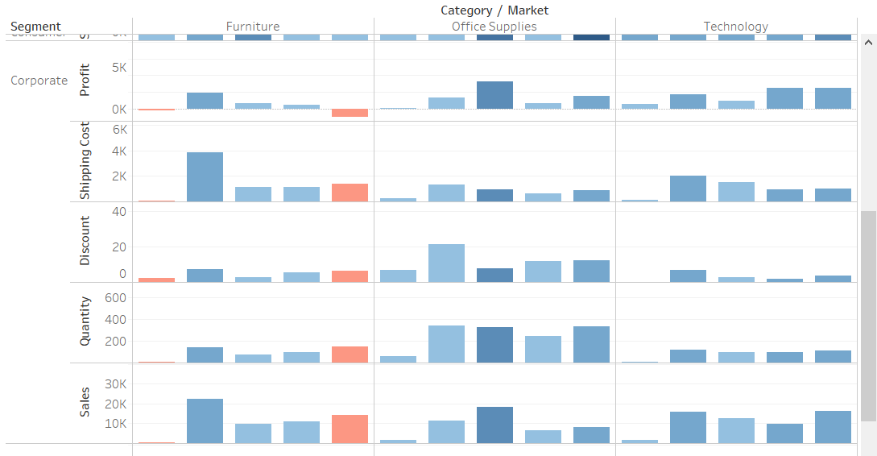

1. The low profit is in the Europe, LATAM as well as Africa region because of (for home office segment and furniture category)
   1. Shipping Cost
   2. Profit
   3. Discount
   4. Quantity
   5. Sales

It can be seen from the screenshot below in the profit sheet.

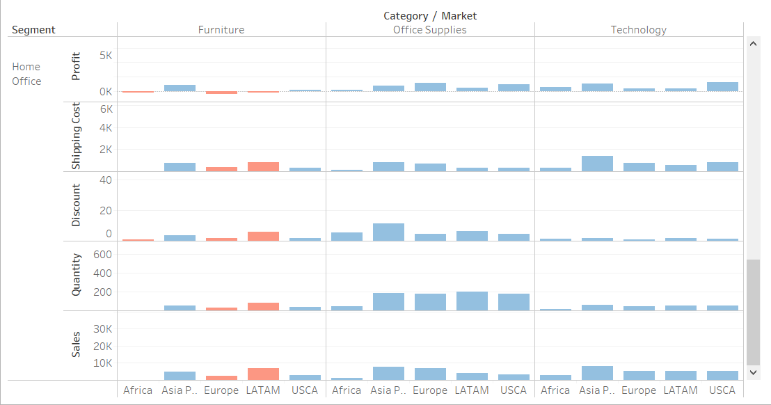

Inside furniture: (seen from cross tab)

a. Tables

b. Bookcases

c. Furnishings

Give the lowest profit.

Inside Office supplies: (seen from cross tab)

a. Arts

b. Supplies

Give the lowest profit.